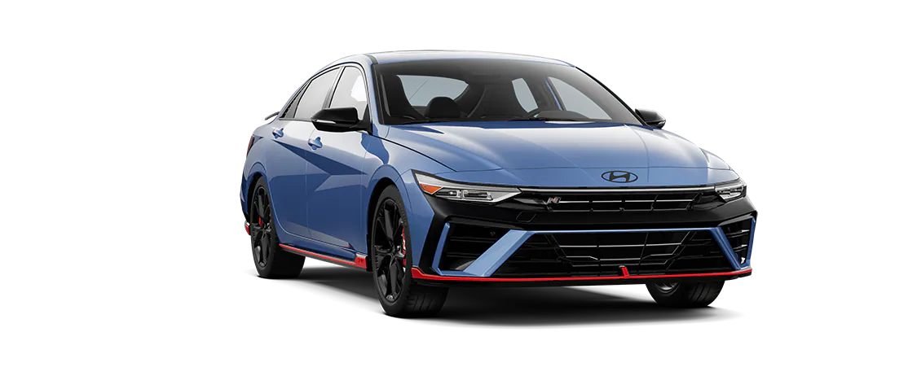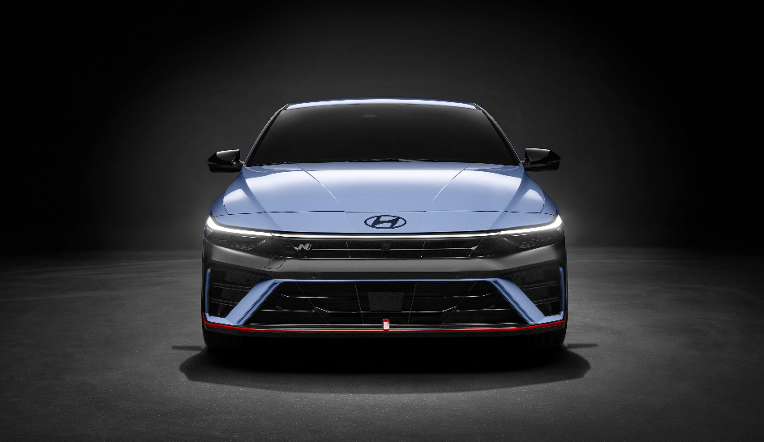

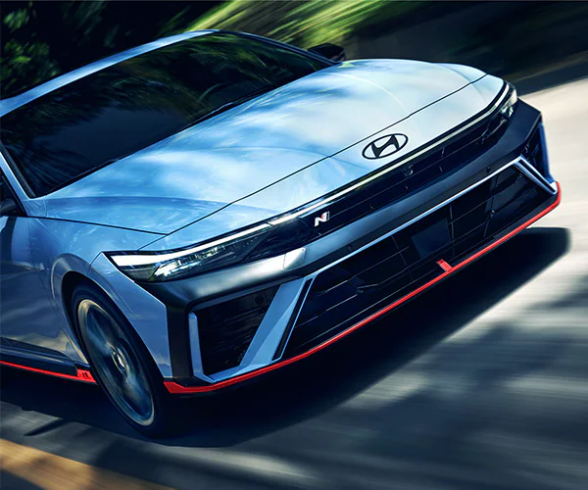

**2025 Hyundai Elantra Engine Specifications**

The 2025 lineup offers two Hyundai Elantra engines. The more powerful of the two is reserved for the higher-performance [Elantra N Line](https://www.ontariohyundai.com/new-vehicles/elantra-n/), though the standard 2.0L engine delivers respectable power for your everyday drives near Puente Hills.

See the Hyundai Elantra engine specs here:

2.0L 4-Cylinder Engine

* **Standard engine on:**SE, SEL Sport, SEL Convenience, Limited
* **Horsepower:** 147 hp @ 6,200 rpm
* **Torque:** 132 lb-ft of torque @ 4,500 rpm

1.6L Turbo GDI 4-Cylinder Engine

* **Standard engine on:**N Line
* **Horsepower:** 201 hp @ 6,000 rpm
* **Torque:** 195 lb-ft of torque @ 1,500-4,500 rpm

2025 Hyundai Elantra MPG

All Elantra models can hold up to 12.4 gallons of fuel and recommend regular unleaded fuel (87 octane) for best results. The expected mileage and range vary by trim, but you can easily drive more than 400 miles on the lower trims. Meanwhile, the N Line achieves more than 375 miles of range.

Here are the Hyundai Elantra specs for the fuel efficiency by trim:

Hyundai Elantra MPG for the SE

* **FWD:**32 city / 41 highway / 36 combined mpg
* **Total range:** 446 miles

Hyundai Elantra MPG for the SEL Sport, SEL Convenience, Limited

* **FWD:**30 city / 39 highway / 34 combined mpg
* **Total range:** 422 miles

Hyundai Elantra MPG for the N Line

* **FWD:**28 city / 35 highway / 31 combined mpg
* **Total range:** 384 miles